Local Image Descriptors

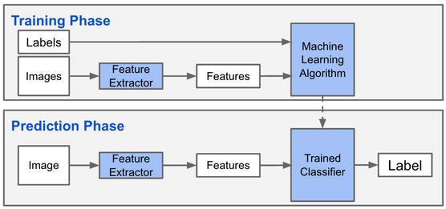

Harris Corner Detector

We define Mi for each point X of the image as a positive semi-definite, symmetric matrix:
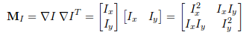

We now have a matrix for each pixel of the image

A Harris matrix is the matrix M to which we apply a weight matrix (typically gaussian filter G)

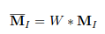
Let lambda1 and lambda2 be M's eigenvalues
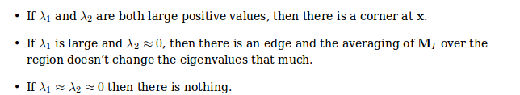

to analyze that, our function will return lamba1 / lambda2, in other words, determinant / trace

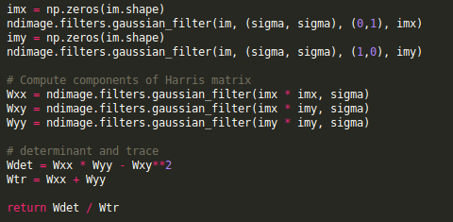

As this is for each pixel, the ouput of the algorithm is a harris_im image

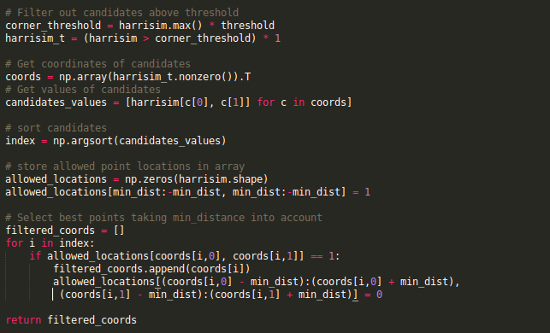
We define a min_dist for convenience to make sure we don't take into account pixels that are too close to the edge of the image. np.nonzero() returns the indices of the pixels which values are superior to threshold, so we get a list of coordinates off the bat

allowed_locations[(coords[i,0] - min_dist):(coords[i,0] + min_dist), (coords[i,1] - min_dist):(coords[i,1] + min_dist)] = 0
is there to thin out the actual points that we will plot on the image; if we find a good candidate, we tell the algorithm to not take into account the neighboring ones

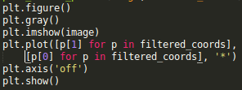
We then plot the points

Finding corresponding points between images

the harris corner detector only gives interest points in images, but does not contain an inherent way of comparing these points between each other

An interest point descriptor is a vector assigned to an interest point that describes the image appearance around the point. We generally combine these two methods together.

We will be studying image patches around each interest point and their graylevel values. If I1(x) and I2(x) are two image patches, the correlation between them is defined as:
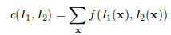

for each pixels x of those patches.

Such a f function can be often the scalar product of the normalized patches I1(x) and I2(x)
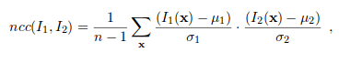

Normal cross correlation between two patches.

Not widely used as unaccurate and slow

SIFT – Scale Invariant Feature transform

SIFT is a very efficient local image descriptor. It features both an interest point detector and a descriptor. SIFT interest point locations are found using Difference of Gaussian functions

Gsigm is the classical 2D gaussian kernel, Isigm is the blurred image through gaussian transformation, and k a constant factor. Bascically we are substracting two blurred versions of the image. Interest points are the maxima of such a transformation, in other words points that stand the test of the substraction

Basically it is a way to describe important visual features in such a way that they are found again even if the size and orientation of them changes in the future. There are two parts to SIFT: keypoint selection and descriptor extraction.
Keypoints are important, salient, easily recognizable features like corners or blobs. Scale invariance is assured by the keypoint selection method. You can recognize such points by smoothing the image with a Gaussian. Noise is eliminated after this filtering but keypoints remain roughly the same.
Once you have the keypoints you need to describe the region around them for future matching. In SIFT you calculate the image gradient first. Then you form histograms of orientation. Histograms for orientation measure how strong the gradient is in each direction. By forming multiple such histograms and concatenating them you obtain a final histogram which will be the descriptor.

Descriptor:
the interest point locator above gives position and scale. To obtain robustness against intensity, it uses image gradients (akin to the normal cross correlation)

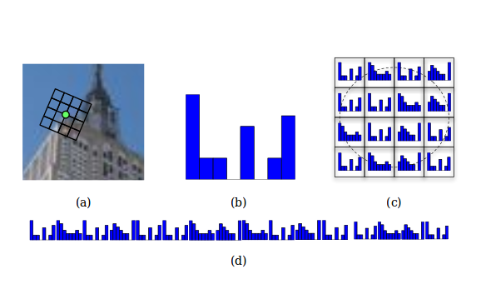
Detecting interest points

SIFT features for an image are computed via the VLFeat package, as doing so ourselves would be unefficient due to complexity.

(a) We define a grid around the interest point, oriented around the gradient dominant direction. (b) We establish a 8-bin histogram over the direction of the gradient in the grid. (c) Those histograms are extracted in each grid location. (d) The histograms are concatenated to form one long feature vector.

The descriptor in SIFT is in fact a flattened histogram of the neighborhood of each keypoint (so a list of 128 values each representing how many pixels in that bin)

The image first needs to be converted into pgm format, where each row contains the coordinates, scale and rotation angle for each interest point, follow by the 128 values of the corresponding descriptor
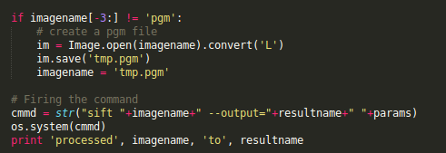

The code is also able to asses the scale of the feature (shown with the circle size). (a) is SIFT, (b) is SIFT with circle indicating scale of feature, (c) is HARRIS points
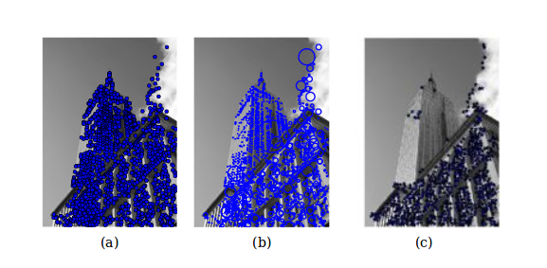
Now for the matching part, We are going to compare the descriptors in our two images, namely the angle between the descriptor vectors.
(p58)

Matching Geo Tagged images

Geotagged images are images with GPS coodinates attached to it

Downloading images from panoramio

http://www.panoramio.com/map/get_panoramas.php?order=popularity&set=public&
from=0&to=20&minx=-180&miny=-90&maxx=180&maxy=90&size=medium

This executes an HTTP get call for a json file

http://www.panoramio.com/map/get_panoramas.php?order=popularity&set=public&
from=0&to=20&minx=-77.037564&miny=38.896662&maxx=-77.035564&maxy=38.898662&size=medium

We have here 20 images around a specified set of coordinates, ordered by popularity

Parsing json with python

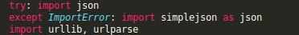

Get json file:
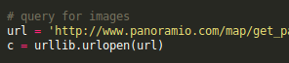

Extract the urls from json file
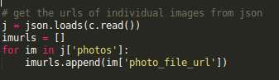

Donwload files present at said urls
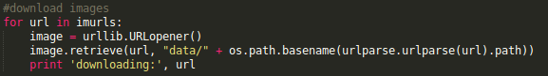

Scale invariant means that if you take two images of the same object where the object is at different scales, the SIFT algorithm will still work on both those images classifying the object the same way

